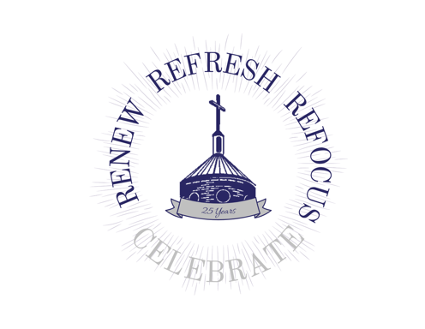

April 12, 2021

Dear :
As we continue in the joy of the Easter Season, I have joyful news to share. September 29th, the Feast of St. Michael the Archangel, marks the 25th anniversary of the dedication of our Church building, and we have big plans. Our theme says it all: “Renew, Refresh, Refocus – and Celebrate!” This event will launch an Anniversary Year filled with special events and new opportunities for us as a parish to grow as a community, get reengaged, and come out of this pandemic more vibrant than ever.
RENEW, REFRESH, REFOCUS
An important component of this Anniversary Year will be a campus-wide capital improvement program, so the buildings on our campus may better serve the mission of our parish and reflect our vibrant and faithful community.
Thanks to your generosity and the Parish’s careful stewardship, the core of these projects is already planned and funded. Our holistic approach to campus renewal, refreshing our facilities and optimizing our use of space, will allow St. Michael’s to refocus its ministries on better serving our community in the years ahead. We have placed special emphasis on enhancing worship, expanding faith formation, supporting our partnership with Catholic Charities, and creating inviting meeting spaces for parish ministries. Within the next 6-24 months, you will enjoy improvements in the following areas:
  - Painting, re-upholstering, and renovation of the Church interior and restrooms;
  - Rebuilding of the Conference Center interior to make it a fitting home for Faith Formation and upgrading the Gallery as a beautiful event and meeting space;
  - Renovating/reconfiguring the ground floor of the Trinity Center into a handicapped-accessible, bright, and welcoming space for ministry gatherings;
  - Resurfacing the parking lot;
  - Landscaping; and more.
Separately, we are already at work completing a security system upgrade, expanding the school playground, and substantially repairing the entry doors of the Church and Parish Center. As we move forward, we are planning carefully to minimize disruption to parish activities and will actively communicate with you throughout to keep you informed and aware of construction impacts.
As we proceed with the above projects, we are exploring opportunities for parishioners to contribute to enhancing or accelerating planned work. There are opportunities to go above and beyond and beautify our campus, especially in the Sanctuary of the Church and the Conference Center. We have requested formal estimates for the cost of these enhancements and will share more information with you as it becomes available.
CELEBRATE
There will be three components to the Anniversary event itself:
- School Mass: Wednesday, September 29th at 8:30 am
- Parish Festival: Saturday, October 2nd (More info to come!)
- Bilingual Anniversary Mass with Bishop Zarama: Sunday, Oct 3rd at 10:30 am
We are staying flexible as we plan these events and will adapt to current conditions related to the pandemic. Visit www.stmichaelcary.org/25Anniversary during the coming months for the latest information on these celebrations and other special events.
YOU ARE INVITED!
We need you to realize the promise of this moment. This work is motivated by serving you, our community, and made possible by you. Many of our plans for the coming year address priorities identified by you during our strategic planning process, and we welcome your ongoing participation, input, and contributions. Following this letter, we will be sending other communications with more details about each part of this initiative. We will also be hosting information sessions for any interested parishioner who would like to learn more. Finally, we invite you to reach out to us at any time at renew@stmcary.org with your questions and ideas or to let us know how you would like to be involved.
These have been challenging times for us all – individually and as a parish. With this anniversary, God is blessing us with the opportunity to join together, celebrate His gifts to us, and reengage as a community of faith. As we prepare to celebrate 25 years together on High House Road, we invite you to “Renew, Refresh, Refocus – and Celebrate!” with us, as we look forward to 25 more.

May God bless you,
Rev. Michael J. Burbeck
Pastor

